Project Assessment

Date: | 05/07/22
Project/policy/service: | OAKWOOD CENTRE – Replace fuse boards, RCBOs, RCD mains switch
Cost | £4,000 est
Priority | 1
Completed by: | Kevin Murray, Deputy Town Clerk

- Project/policy/service information:
This section should identify the project, policy or service change, the method of delivery and the key stakeholders, main beneficiaries and associated aims. It should also include information regarding the Health & Safety, Legal Compliance and Income Impacts.

What is the purpose of the project, policy change or service change and what are the expected outcomes:
Works required to bring electrics up to current standards. Insufficient RCD protection at present – potential for damage/fire risk.

Outline how the project, policy change or service change will be delivered and what governance arrangements are in place or required:
Work will be carried out by a specialist contractor under the supervision of the Amenities Manager
Outline the main beneficiaries of the project, policy change or service change:
Hirers / Visitors / Staff
Impact | Y/N | Detail
Health /Safety Impact | Y | Will improve electrical safety and reduce potential fire risk
Legal Compliance | Y | Electricity at Work Regulations.  Health & Safety at Work Act
Income Impact | Y | Building is key income generator
Other | N

- Equality Impacts - Protected characteristics:

There are 9 protected characteristics as identified by the legislation. Consideration should be given to the potential impacts on each of these groups.
- Race
- Gender
- Disability
- Gender re-assignment
- Age
- Religious belief
- Sexual orientation
- Pregnancy/Maternity
- Marriage and civil partnership

The table below should indicate whether the project, policy change or service change will have a positive or negative impact on any of the protected characteristic groups. Each group should be assessed and assigned a Positive, No, Low or High impact score.

Protected characteristics | Impact score | Please detail what impact will be felt by the protected group
Race | None
Gender | None
Disabilities | None
Age | None
Sexual orientation | None
Religion/belief | None
Gender re-assignment | None
Pregnancy & maternity | None
Marriage & civil partnership | None

Based on the initial impact assessment, a more detailed assessment should be carried out where any groups have been identified as having a low or high negative impact.

- Environmental Impacts

Impact | Y/N | Detail
Carbon impact | N
Habitat/biodiversity impact | N
Alternatives considered | N

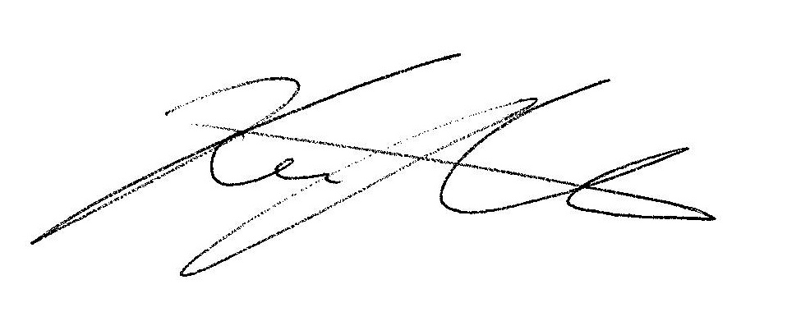

Signed: _________________________________ Print: Kevin Murray Date: 05/07/22

